All Slack General post for FEWD-18

Company-wide announcements and work-based matters

Top of Form



Bottom of Form

Top of Form



Bottom of Form

**\*bold\*** *\_italics\_* ~strike~ `code` ```preformatted``` >quote

**CHANNELS (9)**

* # class-code
* # events
* # general
* # github
* # missing-class
* # office-hours
* # parking-lot
* # random
* # resources

**DIRECT MESSAGES (20)**

* slackbot
* delinda
* evr01
* hilda.lestrange
* jordan-cervantes
* Maryam
* mollymann
* Nazmul
* Nick Grace
* Tim Foley
* Tor Johnson

**Quick SwitcherCtrl+K**

[**#general**](https://dcfewd18.slack.com/archives/general)

This is the very beginning of the [#general](https://dcfewd18.slack.com/archives/general) channel, which was created by [Tim Foley](https://dcfewd18.slack.com/team/timfoley) on October 7th. The purpose of this channel is: *This channel is for team-wide communication and announcements. All team members are in this channel.* (edit).

* [Add an app or custom integration](https://dcfewd18.slack.com/apps/new?channel=C0C2ES869)

* Invite others to this channel

***-----***

**October 7th**

***-----***

[**Tim Foley**](https://dcfewd18.slack.com/team/timfoley) [*[*3:45 PM*]*](https://dcfewd18.slack.com/archives/general/p1444247117660544) *joined #general. Also,*[*@nickgrace*](https://dcfewd18.slack.com/team/nickgrace)*joined,*[*@babybunker*](https://dcfewd18.slack.com/team/babybunker)*joined,*[*@delinda*](https://dcfewd18.slack.com/team/delinda)*joined,*[*@michelebeasley*](https://dcfewd18.slack.com/team/michelebeasley)*joined,*[*@dawnsallas*](https://dcfewd18.slack.com/team/dawnsallas)*joined,*[*@hilda.lestrange*](https://dcfewd18.slack.com/team/hilda.lestrange)*joined,*[*@darynck*](https://dcfewd18.slack.com/team/darynck)*joined,*[*@evr01*](https://dcfewd18.slack.com/team/evr01)*joined.*

***-----***

**October 9th**

***-----***

[**dawnsallas**](https://dcfewd18.slack.com/team/dawnsallas) [*[*2:17 PM*]*](https://dcfewd18.slack.com/archives/general/p1444414676000005) hey [@timfoley](https://dcfewd18.slack.com/team/timfoley) was wondering if Sublime is mandatory or can we use Atom?

[**Tim Foley**](https://dcfewd18.slack.com/team/timfoley) [*[*2:21 PM*]*](https://dcfewd18.slack.com/archives/general/p1444414874000006) Nope! You’re welcome to use Atom (I’m personally a fan!) as long as you’re okay with the fact that Tor and Nick will be teaching using Sublime. It’ll look similar, but some functions might be a bit different.

[**dawnsallas**](https://dcfewd18.slack.com/team/dawnsallas) [*[*2:22 PM*]*](https://dcfewd18.slack.com/archives/general/p1444414943000007) Cool. yeah our devs here where i work turned me onto Atom….they prefer using it. I’ll give it a try at first…may revert to Sublime if it becomes a problem.

[**Nazmul**](https://dcfewd18.slack.com/team/nazslack) [*[*3:13 PM*]*](https://dcfewd18.slack.com/archives/general/p1444418011000008) *joined #general. Also,*[*@mollymann*](https://dcfewd18.slack.com/team/mollymann)*joined,*[*@mattk045*](https://dcfewd18.slack.com/team/mattk045)*joined,*[*@jordan-cervantes*](https://dcfewd18.slack.com/team/jordan-cervantes)*joined,*[*@mary-m*](https://dcfewd18.slack.com/team/mary-m)*joined,*[*@crystalthomas0213*](https://dcfewd18.slack.com/team/crystalthomas0213)*joined,*[*@hasahm*](https://dcfewd18.slack.com/team/hasahm)*joined,*[*@jennyroche13*](https://dcfewd18.slack.com/team/jennyroche13)*joined,*[*@sonya8641*](https://dcfewd18.slack.com/team/sonya8641)*joined.*

***-----***

**October 10th**

***-----***

[**Tim Foley**](https://dcfewd18.slack.com/team/timfoley) [*[*12:13 PM*]*](https://dcfewd18.slack.com/archives/general/p1444493592000006) **@group** Slides! <https://github.com/ga-students/FEWD-DC-18/blob/master/Week_01_Basics/01_html_basics/slides.md>

[**Nick Grace**](https://dcfewd18.slack.com/team/nickgrace) [*[*5:02 PM*]*](https://dcfewd18.slack.com/archives/general/p1444510946000007) Course Repo: <https://github.com/ga-students/FEWD-DC-18>

[**Tim Foley**](https://dcfewd18.slack.com/team/timfoley) [*[*5:04 PM*]*](https://dcfewd18.slack.com/archives/general/p1444511082000008) **@group** assignment description and rubric <https://github.com/ga-students/FEWD-DC-18/tree/master/Week_01_Basics/Assignment>

[**Tor Johnson**](https://dcfewd18.slack.com/team/kasigi) [*[*11:09 PM*]*](https://dcfewd18.slack.com/archives/general/p1444532989000002) *joined #general*

***-----***

**October 14th**

***-----***

[**mollymann**](https://dcfewd18.slack.com/team/mollymann) [*[*7:42 PM*]*](https://dcfewd18.slack.com/archives/general/p1444866133000002) what is the link we post for the hw, where do i find that?

[**Nick Grace**](https://dcfewd18.slack.com/team/nickgrace) [*[*7:43 PM*]*](https://dcfewd18.slack.com/archives/general/p1444866206000003) [@mollymann](https://dcfewd18.slack.com/team/mollymann): Here is the link: <http://goo.gl/forms/T0smvhvxig>

[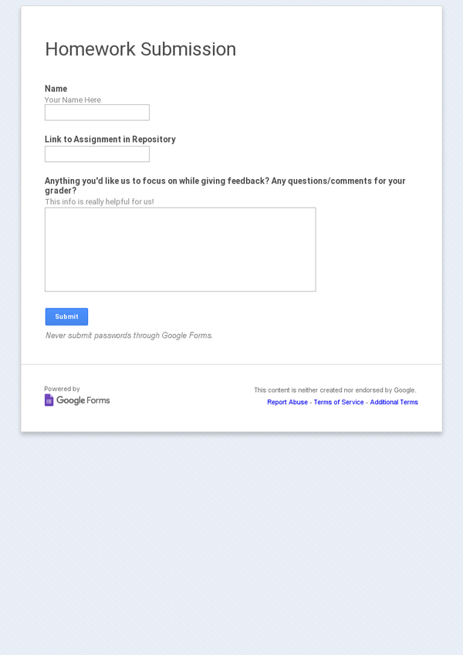](http://goo.gl/forms/T0smvhvxig)

Google Docs

[**Homework Submission**](http://goo.gl/forms/T0smvhvxig)

Google Drive

[**mollymann**](https://dcfewd18.slack.com/team/mollymann) [*[*7:50 PM*]*](https://dcfewd18.slack.com/archives/general/p1444866657000005) i mean the link it github, after i submit, what link do I copy and paste in?

[**Nick Grace**](https://dcfewd18.slack.com/team/nickgrace) [*[*7:53 PM*]*](https://dcfewd18.slack.com/archives/general/p1444866792000006) Copy the link to your personal github homework location/repo.

[​*[*7:53*]*](https://dcfewd18.slack.com/archives/general/p1444866818000007)

For example, mine is: <https://github.com/nickgrace/dcfewd18hw>

[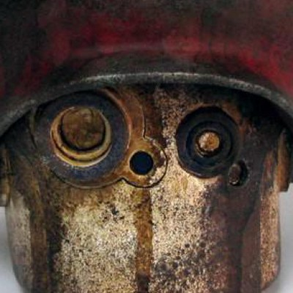](https://github.com/nickgrace/dcfewd18hw)

GitHub

[**nickgrace/dcfewd18hw**](https://github.com/nickgrace/dcfewd18hw)

Contribute to dcfewd18hw development by creating an account on GitHub.

[​*[*7:53*]*](https://dcfewd18.slack.com/archives/general/p1444866826000009)

Yours should be similar to this.

[**mollymann**](https://dcfewd18.slack.com/team/mollymann) [*[*7:57 PM*]*](https://dcfewd18.slack.com/archives/general/p1444867051000010) ok thanks

***-----***

**October 17th**

***-----***

[**Nick Grace**](https://dcfewd18.slack.com/team/nickgrace) [*[*2:18 PM*]*](https://dcfewd18.slack.com/archives/general/p1445105889000011) This week's homework: <https://github.com/ga-students/FEWD-DC-18/tree/master/Week_02_Styling/Assignment>

[**Nick Grace**](https://dcfewd18.slack.com/team/nickgrace) [*[*4:31 PM*]*](https://dcfewd18.slack.com/archives/general/p1445113865000012) Homework: <https://github.com/ga-students/FEWD-DC-18/tree/master/Week_02_Styling/Assignment>

***-----***

**October 24th**

***-----***

[**Nick Grace**](https://dcfewd18.slack.com/team/nickgrace) [*[*11:28 AM*]*](https://dcfewd18.slack.com/archives/general/p1445700521000013) [uploaded a file](https://dcfewd18.slack.com/files/nickgrace/F0D4J8RA8/layouts.pdf)

**[layouts.pdf](https://files.slack.com/files-pri/T0C2CGPDH-F0D4J8RA8/layouts.pdf" \t "new_1450536031286)**

[54KBPDF Click to open original](https://files.slack.com/files-pri/T0C2CGPDH-F0D4J8RA8/layouts.pdf" \t "new_1450536031286)

[**Add Comment**](https://dcfewd18.slack.com/files/nickgrace/F0D4J8RA8/layouts.pdf)

[**Nick Grace**](https://dcfewd18.slack.com/team/nickgrace) [*[*5:11 PM*]*](https://dcfewd18.slack.com/archives/general/p1445721097000014) Please let us know how we are doing! :<http://goo.gl/forms/LR2DlrCPtS>

[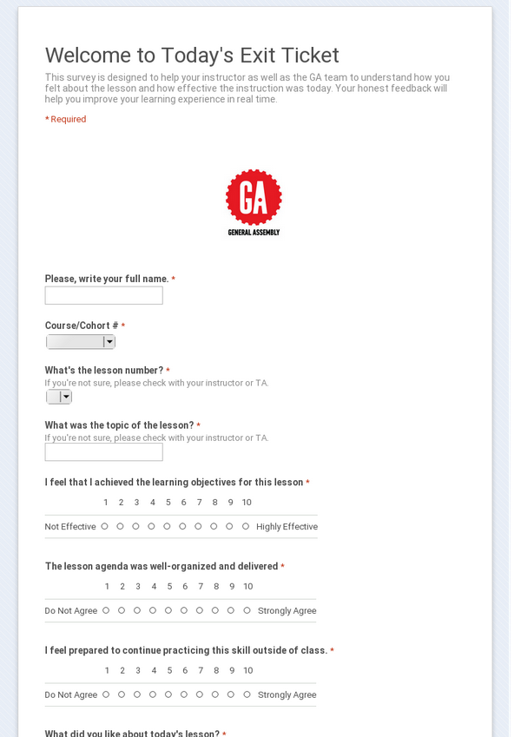](http://goo.gl/forms/LR2DlrCPtS)

Google Docs

[**Welcome to Today's Exit Ticket**](http://goo.gl/forms/LR2DlrCPtS)

This survey is designed to help your instructor as well as the GA team to understand how you felt about the lesson and how effective the instruction was today. Your honest feedback will help you improve your learning experience in real time.

***-----***

**October 27th**

***-----***

[**hilda.lestrange**](https://dcfewd18.slack.com/team/hilda.lestrange) [*[*7:44 AM*]*](https://dcfewd18.slack.com/archives/general/p1445946264000016) FYI for everyone, in case you run into this problem too! I couldn’t get some of my CSS changes to show up in the browser. In order to make the browser to show my CSS, I had to change the order of the links in the <head> of my HTML file. Make sure that the link to your CSS file is last! Otherwise I think the reset CSS file overrides your CSS file.

[**Hasan**](https://dcfewd18.slack.com/team/hasahm) [*[*8:15 AM*]*](https://dcfewd18.slack.com/archives/general/p1445948121000017) Question for the all - does anyone have html/css for the layout challenge (layout.pdf) they'd be willing to share to the group? Would be awesome to compare my beatup code with something more solid...

[**hilda.lestrange**](https://dcfewd18.slack.com/team/hilda.lestrange) [*[*8:22 AM*]*](https://dcfewd18.slack.com/archives/general/p1445948549000018) [@hasahm](https://dcfewd18.slack.com/team/hasahm): which layout would you want to see? I wrote over my CSS file so I only have the 3rd layout :grin:

[**hilda.lestrange**](https://dcfewd18.slack.com/team/hilda.lestrange) [*[*8:25 AM*]*](https://dcfewd18.slack.com/archives/general/p1445948732000019) [uploaded and commented on a file](https://dcfewd18.slack.com/files/hilda.lestrange/F0D8Y11ML/layout_challenge_3.zip)

**[Layout\_Challenge\_3.zip](https://files.slack.com/files-pri/T0C2CGPDH-F0D8Y11ML/download/layout_challenge_3.zip" \t "new_1450536031286)**

[ZipClick to download](https://files.slack.com/files-pri/T0C2CGPDH-F0D8Y11ML/download/layout_challenge_3.zip" \t "new_1450536031286)

[**1 Comment**](https://dcfewd18.slack.com/files/hilda.lestrange/F0D8Y11ML/layout_challenge_3.zip)

Feel free to check out my solution for layout 3 :simple\_smile:

[**Hasan**](https://dcfewd18.slack.com/team/hasahm) [*[*8:56 AM*]*](https://dcfewd18.slack.com/archives/general/p1445950572000020) ahh that's the one i'm stuck on.. thanks

[**Tor Johnson**](https://dcfewd18.slack.com/team/kasigi) [*[*11:15 AM*]*](https://dcfewd18.slack.com/archives/general/p1445958922000021) hi Hilda! You've just highlighted something crucial and 100% correct.  In CSS, order does matter.  Browsers will obey whichever css selector is used 'last'.  That means that the last file will override the first file.  Within a file, the bottom line will override the top line if they are applying to the same elements.

[**dawnsallas**](https://dcfewd18.slack.com/team/dawnsallas) [*[*12:04 PM*]*](https://dcfewd18.slack.com/archives/general/p1445961872000022) so make sure the styles.css is last or reset.css is last?

[**Nick Grace**](https://dcfewd18.slack.com/team/nickgrace) [*[*12:13 PM*]*](https://dcfewd18.slack.com/archives/general/p1445962389000023) make sure that your custom styles stylesheet is last.

***-----***

**October 28th**

***-----***

[**Tim Foley**](https://dcfewd18.slack.com/team/timfoley) [*[*6:14 PM*]*](https://dcfewd18.slack.com/archives/general/p1446070499000024) **@group** Hi all! FYI you all get a sweet 30% discount on any one-off Class or Workshop (<https://generalassemb.ly/education?format=classes-workshops>) we offer here on campus. Use the code**​\*back2school-dc\*​** for that 30% off. Check it out!

[**Web Design, Business, Technology Classes and Immersives**](https://generalassemb.ly/education?format=classes-workshops)

General Assembly hosts business, design, and technology courses, classes, and workshops.

***-----***

**October 31st**

***-----***

[**Nick Grace**](https://dcfewd18.slack.com/team/nickgrace) [*[*10:08 AM*]*](https://dcfewd18.slack.com/archives/general/p1446300537000026) [uploaded a file](https://dcfewd18.slack.com/files/nickgrace/F0DJE2J3A/relaxr-solution_code.zip)

**[relaxr-solution\_code.zip](https://files.slack.com/files-pri/T0C2CGPDH-F0DJE2J3A/download/relaxr-solution_code.zip" \t "new_1450536031286)**

[2MBZip Click to download](https://files.slack.com/files-pri/T0C2CGPDH-F0DJE2J3A/download/relaxr-solution_code.zip" \t "new_1450536031286)

[**Add Comment**](https://dcfewd18.slack.com/files/nickgrace/F0DJE2J3A/relaxr-solution_code.zip)

[**Nick Grace**](https://dcfewd18.slack.com/team/nickgrace) [*[*12:34 PM*]*](https://dcfewd18.slack.com/archives/general/p1446309241000027) <http://codepen.io/nickgrace/pen/wLtHA>

CodePen

[**Color Switcher (JS) Starter Code**](http://codepen.io/nickgrace/pen/wLtHA)

GA FEWD9... (18KB)

[[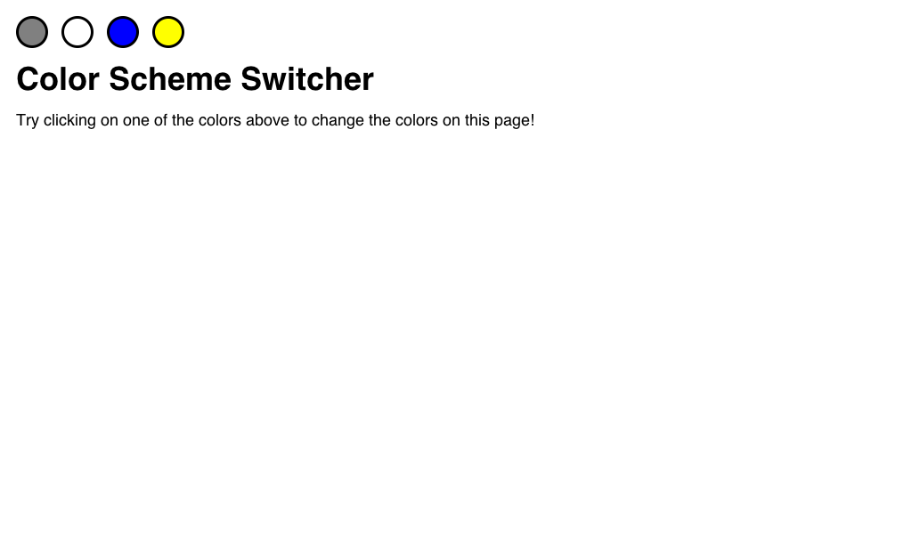](http://codepen.io/nickgrace/pen/wLtHA)](http://codepen.io/nickgrace/pen/wLtHA" \o "" \t "_blank)

[**Nick Grace**](https://dcfewd18.slack.com/team/nickgrace) [*[*1:17 PM*]*](https://dcfewd18.slack.com/archives/general/p1446311823000029) <http://codepen.io/nickgrace/pen/ImHdK>

CodePen

[**Traffic Light (Starter Code)**](http://codepen.io/nickgrace/pen/ImHdK)

GA FEWD9... (21KB)

[[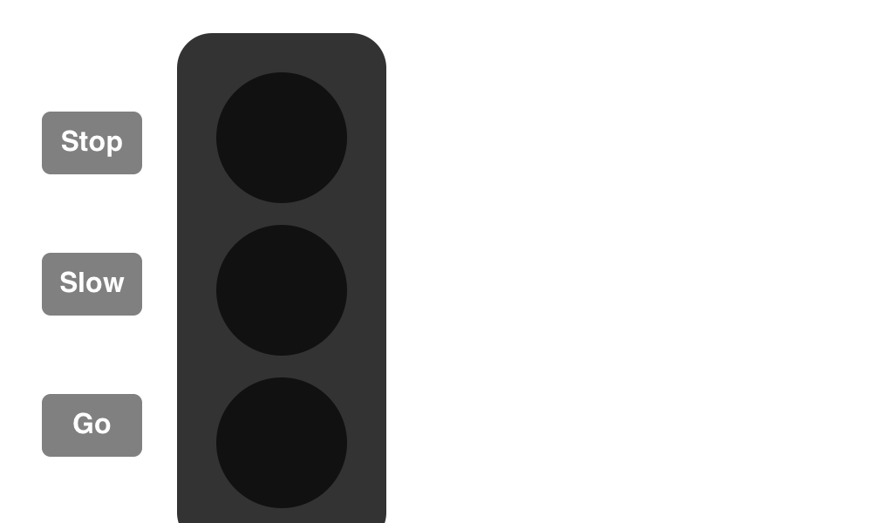](http://codepen.io/nickgrace/pen/ImHdK)](http://codepen.io/nickgrace/pen/ImHdK" \o "" \t "_blank)

[**Tor Johnson**](https://dcfewd18.slack.com/team/kasigi) [*[*4:30 PM*]*](https://dcfewd18.slack.com/archives/general/p1446323444000033) <http://codepen.io/nevan/pen/mKzvs>

CodePen

[**FAQs - 5**](http://codepen.io/nevan/pen/mKzvs)

... (25KB)

[[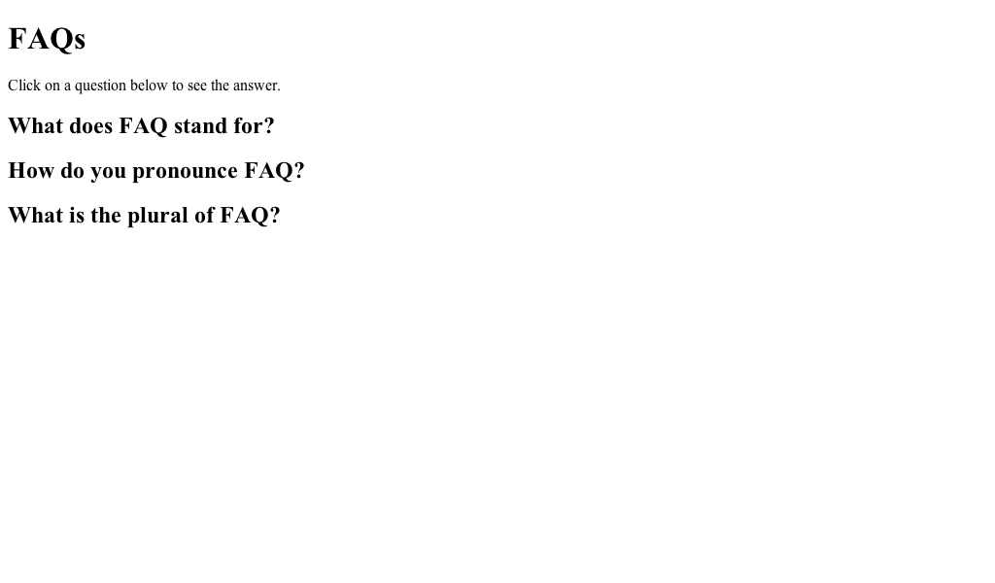](http://codepen.io/nevan/pen/mKzvs)](http://codepen.io/nevan/pen/mKzvs" \o "" \t "_blank)

[**Tor Johnson**](https://dcfewd18.slack.com/team/kasigi) [*[*4:52 PM*]*](https://dcfewd18.slack.com/archives/general/p1446324727000036)

```<script src="https://ajax.googleapis.com/ajax/libs/jquery/1.11.3/jquery.min.js"></script>```

[**Tor Johnson**](https://dcfewd18.slack.com/team/kasigi) [*[*5:04 PM*]*](https://dcfewd18.slack.com/archives/general/p1446325468000037) <https://docs.google.com/forms/d/1YObQ3aITpYUi7pmEZUG-4K1Z8HGCYYSGjfoii-7XbF8/viewform?c=0&w=1>

[](https://docs.google.com/forms/d/1YObQ3aITpYUi7pmEZUG-4K1Z8HGCYYSGjfoii-7XbF8/viewform?c=0&w=1)

Google Docs

[**Welcome to Today's Exit Ticket**](https://docs.google.com/forms/d/1YObQ3aITpYUi7pmEZUG-4K1Z8HGCYYSGjfoii-7XbF8/viewform?c=0&w=1)

This survey is designed to help your instructor as well as the GA team to understand how you felt about the lesson and how effective the instruction was today. Your honest feedback will help you improve your learning experience in real time.

***-----***

**November 3rd**

***-----***

[**Adam Bray**](https://dcfewd18.slack.com/team/adam.bray) [*[*3:27 PM*]*](https://dcfewd18.slack.com/archives/general/p1446582437000039) *joined #general*

[**Maryam**](https://dcfewd18.slack.com/team/mary-m) [*[*6:20 PM*]*](https://dcfewd18.slack.com/archives/general/p1446592830000040) Hi! I am stuck on this week's assignment! I don't know where to begin :disappointed: Can someone please explain what this means "Use in-line-block or floats in your CSS to achieve a two-column layout- Prevent a form submission with the event.preventDefault() function"

[**hilda.lestrange**](https://dcfewd18.slack.com/team/hilda.lestrange) [*[*7:00 PM*]*](https://dcfewd18.slack.com/archives/general/p1446595258000041) Hey [@mary-m](https://dcfewd18.slack.com/team/mary-m) :simple\_smile:  I think the first part is saying you should use float: left; to make the divs float next to each other. That will make a two column layout like this:

[**hilda.lestrange**](https://dcfewd18.slack.com/team/hilda.lestrange) [*[*7:01 PM*]*](https://dcfewd18.slack.com/archives/general/p1446595278000042) [uploaded an image: two column layout](https://dcfewd18.slack.com/files/hilda.lestrange/F0DQ9ABHN/screen_shot_2015-11-03_at_6.59.23_pm.png)

[**Add Comment**](https://dcfewd18.slack.com/files/hilda.lestrange/F0DQ9ABHN/screen_shot_2015-11-03_at_6.59.23_pm.png)

[**hilda.lestrange**](https://dcfewd18.slack.com/team/hilda.lestrange) [*[*7:02 PM*]*](https://dcfewd18.slack.com/archives/general/p1446595331000043) the second part is saying you need to write a jquery function that prevents the page from scrolling to the top when you click the “Read More” links

[​*[*7:03*]*](https://dcfewd18.slack.com/archives/general/p1446595412000044)

this is how I got that to work:

[​*[*7:04*]*](https://dcfewd18.slack.com/archives/general/p1446595490000045)

```jQuery(document).ready(function(){  
  
// Prevent link from scrolling to the top of the page  
  jQuery(".toggle-story-1").click(function(event) {  
    event.preventDefault();  
  });  
});  
```

[​*[*7:08*]*](https://dcfewd18.slack.com/archives/general/p1446595696000046)

the “Read More” link in my html had a class of “.toggle-story-1”, so that jquery function is saying when clicking anything with a class of “.toggle-story-1” prevent the default action (which is scrolling to the top of the page)

[​*[*7:09*]*](https://dcfewd18.slack.com/archives/general/p1446595754000047)

It took me a long time to figure it out! I found this by searching google, which helped:  <http://api.jquery.com/event.preventdefault/>

jQuery: The Write Less, Do More, JavaScript Library

[**Maryam**](https://dcfewd18.slack.com/team/mary-m) [*[*7:54 PM*]*](https://dcfewd18.slack.com/archives/general/p1446598453000049) Thanks Hilda! That helps a lot!

[**hilda.lestrange**](https://dcfewd18.slack.com/team/hilda.lestrange) [*[*9:06 PM*]*](https://dcfewd18.slack.com/archives/general/p1446602801000050) No problem! :relaxed:

***-----***

**November 4th**

***-----***

[**Nick Grace**](https://dcfewd18.slack.com/team/nickgrace) [*[*11:17 AM*]*](https://dcfewd18.slack.com/archives/general/p1446653821000002) [@hilda.lestrange](https://dcfewd18.slack.com/team/hilda.lestrange): [@mary-m](https://dcfewd18.slack.com/team/mary-m): Sorry Tor and I weren't available last night to help. Great teamwork here!

[**hilda.lestrange**](https://dcfewd18.slack.com/team/hilda.lestrange) [*[*11:20 AM*]*](https://dcfewd18.slack.com/archives/general/p1446654036000003) :thumbsup:

***-----***

**November 5th**

***-----***

[**evr01**](https://dcfewd18.slack.com/team/evr01) [*[*2:54 PM*]*](https://dcfewd18.slack.com/archives/general/p1446753281000004) Quick question, how are going to send in our mock-up's?

[**mollymann**](https://dcfewd18.slack.com/team/mollymann) [*[*6:59 PM*]*](https://dcfewd18.slack.com/archives/general/p1446767961000005) I think we just need a sketch for class

[​*[*6:59*]*](https://dcfewd18.slack.com/archives/general/p1446767964000006)

maybe

[**Nick Grace**](https://dcfewd18.slack.com/team/nickgrace) [*[*7:02 PM*]*](https://dcfewd18.slack.com/archives/general/p1446768170000007) [@evr01](https://dcfewd18.slack.com/team/evr01): Good question. Let's create a folder in your dcfewd18hw directory called final-project and drop the wireframes or text file with 1 paragraph idea there.

***-----***

**November 7th**

***-----***

[**Nick Grace**](https://dcfewd18.slack.com/team/nickgrace) [*[*4:40 PM*]*](https://dcfewd18.slack.com/archives/general/p1446932438000002) Please fill out the class exit form: <http://goo.gl/forms/LR2DlrCPtS>

[](http://goo.gl/forms/LR2DlrCPtS)

Google Docs

[**Welcome to Today's Exit Ticket**](http://goo.gl/forms/LR2DlrCPtS)

This survey is designed to help your instructor as well as the GA team to understand how you felt about the lesson and how effective the instruction was today. Your honest feedback will help you improve your learning experience in real time.

***-----***

**November 8th**

***-----***

[**Nick Grace**](https://dcfewd18.slack.com/team/nickgrace) [*[*6:55 PM*]*](https://dcfewd18.slack.com/archives/general/p1447026917000004) NationJS Conference is coming to Silver Spring this week! Check out the program and also the pre-party information. [http://nationjs.com](http://nationjs.com/)

***-----***

**November 9th**

***-----***

[**Tim Foley**](https://dcfewd18.slack.com/team/timfoley) [*[*5:19 PM*]*](https://dcfewd18.slack.com/archives/general/p1447107541000005) **@group** GA now has our very own PB&J Station! Check it out over in the kitchenette. We’re new at this, so please send me your feedback if you’ve got it (e.g. bread ran out by 8pm, chunky peanut butter is too chunky, we love the PB&J station, etc.)

***-----***

**November 12th**

***-----***

[**Tim Foley**](https://dcfewd18.slack.com/team/timfoley) [*[*2:30 PM*]*](https://dcfewd18.slack.com/archives/general/p1447356604000002) **@group** thanks to everyone who’s filled out the Mid-Course survey! If you haven’t already, please take a moment to submit your responses.

***-----***

**December 5th**

***-----***

[https://slack.global.ssl.fastly.net/6f04/img/services/hangouts_48.png](https://dcfewd18.slack.com/services/B0CD3SQFJ)

[**hangouts**](https://dcfewd18.slack.com/services/B0CD3SQFJ)BOT [*[*10:07 AM*]*](https://dcfewd18.slack.com/archives/general/p1449328065000005) [@nickgrace](https://dcfewd18.slack.com/team/nickgrace) has started a Google+ Hangout for this channel. [Click here to join](https://plus.google.com/hangouts/_/xtm7y6brjmisqlmh4tnxm2ih7aa).

[**Nick Grace**](https://dcfewd18.slack.com/team/nickgrace) [*[*10:07 AM*]*](https://dcfewd18.slack.com/archives/general/p1449328078000006) We will try a hangout for folks offsite today!

[**dawnsallas**](https://dcfewd18.slack.com/team/dawnsallas) [*[*2:35 PM*]*](https://dcfewd18.slack.com/archives/general/p1449344119000007) will yall let me know when class is back in session? :simple\_smile:

[**evr01**](https://dcfewd18.slack.com/team/evr01) [*[*2:40 PM*]*](https://dcfewd18.slack.com/archives/general/p1449344401000008) it's back in session

***-----***

**December 8th**

***-----***

[**Tim Foley**](https://dcfewd18.slack.com/team/timfoley) [*[*5:28 PM*]*](https://dcfewd18.slack.com/archives/general/p1449613713000009) **@group** Exciting news! I’m about to invite you to all to the GA DC Campus Slack team. It used to be alumni-exclusive, but we’ve decided to open it up to current students as well. Check it out! It’s a great way to chat with other FEWD students, but also to connect with students from the other courses. See you there!

***-----***

**December 12th**

***-----***

[**hilda.lestrange**](https://dcfewd18.slack.com/team/hilda.lestrange) [*[*8:37 AM*]*](https://dcfewd18.slack.com/archives/general/p1449927447000010) [@nickgrace](https://dcfewd18.slack.com/team/nickgrace): [@kasigi](https://dcfewd18.slack.com/team/kasigi) Hey guys, Dawn and I both need to participate remotely today from Richmond. Could you make a Google hangout for us when the time comes?

[**Nick Grace**](https://dcfewd18.slack.com/team/nickgrace) [*[*8:55 AM*]*](https://dcfewd18.slack.com/archives/general/p1449928559000011) [@hilda.lestrange](https://dcfewd18.slack.com/team/hilda.lestrange): [@kasigi](https://dcfewd18.slack.com/team/kasigi) [@dawnsallas](https://dcfewd18.slack.com/team/dawnsallas) No problem. Majority of day will be lab.

[**hilda.lestrange**](https://dcfewd18.slack.com/team/hilda.lestrange) [*[*9:02 AM*]*](https://dcfewd18.slack.com/archives/general/p1449928946000012) ok great, thank you!

[**Nick Grace**](https://dcfewd18.slack.com/team/nickgrace) [*[*10:16 AM*]*](https://dcfewd18.slack.com/archives/general/p1449933386000013) Hangout will start shortly!

[**hilda.lestrange**](https://dcfewd18.slack.com/team/hilda.lestrange) [*[*10:18 AM*]*](https://dcfewd18.slack.com/archives/general/p1449933502000014) :thumbsup:

[https://slack.global.ssl.fastly.net/6f04/img/services/hangouts_48.png](https://dcfewd18.slack.com/services/B0CD3SQFJ)

[**hangouts**](https://dcfewd18.slack.com/services/B0CD3SQFJ)BOT [*[*10:26 AM*]*](https://dcfewd18.slack.com/archives/general/p1449933993000015) [@nickgrace](https://dcfewd18.slack.com/team/nickgrace) has started a Google+ Hangout for this channel. [Click here to join](https://plus.google.com/hangouts/_/apjccfqeeytp7uwptqmqusgn6ea).

[**Nick Grace**](https://dcfewd18.slack.com/team/nickgrace) [*[*10:26 AM*]*](https://dcfewd18.slack.com/archives/general/p1449934005000016) Hangout has started!

[**hilda.lestrange**](https://dcfewd18.slack.com/team/hilda.lestrange) [*[*11:45 AM*]*](https://dcfewd18.slack.com/archives/general/p1449938700000017) [@nickgrace](https://dcfewd18.slack.com/team/nickgrace): do you have us muted?

[​*[*11:45*]*](https://dcfewd18.slack.com/archives/general/p1449938744000018)

[@kasigi](https://dcfewd18.slack.com/team/kasigi): do you know if Nick has us muted?

[**Nick Grace**](https://dcfewd18.slack.com/team/nickgrace) [*[*12:02 PM*]*](https://dcfewd18.slack.com/archives/general/p1449939738000019) <http://www.webdesignerdepot.com/2014/05/how-to-create-an-animated-sticky-header-with-css3-and-jquery/>

[](http://www.webdesignerdepot.com/2014/05/how-to-create-an-animated-sticky-header-with-css3-and-jquery/)

Webdesigner Depot

[**How to create an animated sticky header, with CSS3 and jQuery**](http://www.webdesignerdepot.com/2014/05/how-to-create-an-animated-sticky-header-with-css3-and-jquery/)

Trends come and trends go. The ones that stick around the longest do so because they solve a particular problem. A trend that's popular right now for that very reason, is sticky elements; elements th

[**Nick Grace**](https://dcfewd18.slack.com/team/nickgrace) [*[*2:21 PM*]*](https://dcfewd18.slack.com/archives/general/p1449948062000021) **@group**: We are back online!

[https://slack.global.ssl.fastly.net/6f04/img/services/hangouts_48.png](https://dcfewd18.slack.com/services/B0CD3SQFJ)

[**hangouts**](https://dcfewd18.slack.com/services/B0CD3SQFJ)BOT [*[*2:21 PM*]*](https://dcfewd18.slack.com/archives/general/p1449948070000022) [@nickgrace](https://dcfewd18.slack.com/team/nickgrace) has started a Google+ Hangout for this channel. [Click here to join](https://plus.google.com/hangouts/_/pivgd3uhaih2oqndlle5r6ndzya).

[**dawnsallas**](https://dcfewd18.slack.com/team/dawnsallas) [*[*2:21 PM*]*](https://dcfewd18.slack.com/archives/general/p1449948111000023) cool! Hilda has to run home real quick but she will be back in about 15 mins.

[**Nick Grace**](https://dcfewd18.slack.com/team/nickgrace) [*[*2:21 PM*]*](https://dcfewd18.slack.com/archives/general/p1449948118000024) np!

[​*[*2:22*]*](https://dcfewd18.slack.com/archives/general/p1449948125000025)

we have a new han gout link above

[**hilda.lestrange**](https://dcfewd18.slack.com/team/hilda.lestrange) [*[*4:13 PM*]*](https://dcfewd18.slack.com/archives/general/p1449954837000026) Thanks for accommodating us [@nickgrace](https://dcfewd18.slack.com/team/nickgrace) [@kasigi](https://dcfewd18.slack.com/team/kasigi)!  We’re signing off now :simple\_smile:

***-----***

**December 14th**

***-----***

[**sonya8641**](https://dcfewd18.slack.com/team/sonya8641) [*[*8:35 AM*]*](https://dcfewd18.slack.com/archives/general/p1450100132000027) how can I add content to my nav pages.....Change the image to the nav pages

[**Nick Grace**](https://dcfewd18.slack.com/team/nickgrace) [*[*9:56 AM*]*](https://dcfewd18.slack.com/archives/general/p1450105002000028) [@sonya8641](https://dcfewd18.slack.com/team/sonya8641): On each separate page, you can add a class to the body tag, like

```<body class="about">```

. Then, you can change the hero image by adding a declaration like this to your CSS:

```.about .hero {background:url(images/image.jpg);}```

***-----***

**December 15th**

***-----***

[**Tim Foley**](https://dcfewd18.slack.com/team/timfoley) [*[*4:57 PM*]*](https://dcfewd18.slack.com/archives/general/p1450216644000029) **@group** Can’t believe FEWD18 is ending on Saturday—whoa! I’m really looking forward to seeing your final projects. That’s always my favorite part of every class. If you haven’t already, please take a moment to fill out your **​\*End of Course Survey\*​**. Think of it as a nice break if you get tired of javascript :stuck\_out\_tongue:

***-----***

**December 16th**

***-----***

[**delinda**](https://dcfewd18.slack.com/team/delinda) [*[*4:09 PM*]*](https://dcfewd18.slack.com/archives/general/p1450300182000030) [@timfoley](https://dcfewd18.slack.com/team/timfoley) Who gets tired of JavaScript??? :wink:

[**Tim Foley**](https://dcfewd18.slack.com/team/timfoley) [*[*4:10 PM*]*](https://dcfewd18.slack.com/archives/general/p1450300204000031) hahaaa I know I sometimes get tired of JavaScript beating me up :stuck\_out\_tongue:

***-----***

**Today**

***December 19th, 2015 -----***

[**sonya8641**](https://dcfewd18.slack.com/team/sonya8641) [*[*9:42 AM*]*](https://dcfewd18.slack.com/archives/general/p1450536152000032) Where is the survey?

[**Nick Grace**](https://dcfewd18.slack.com/team/nickgrace) [*[*9:45 AM*]*](https://dcfewd18.slack.com/archives/general/p1450536342000033) [@sonya8641](https://dcfewd18.slack.com/team/sonya8641): I think Tim has emailed it to everyone.